Single write test:
Sequence is :
req.w_r==WRITE_ONLY; req.awaddr==4; req.awvalid==1; req.wvalid==1; req.wid==awid; req.awburst==1; req.awlen==3; req.awsize==2;
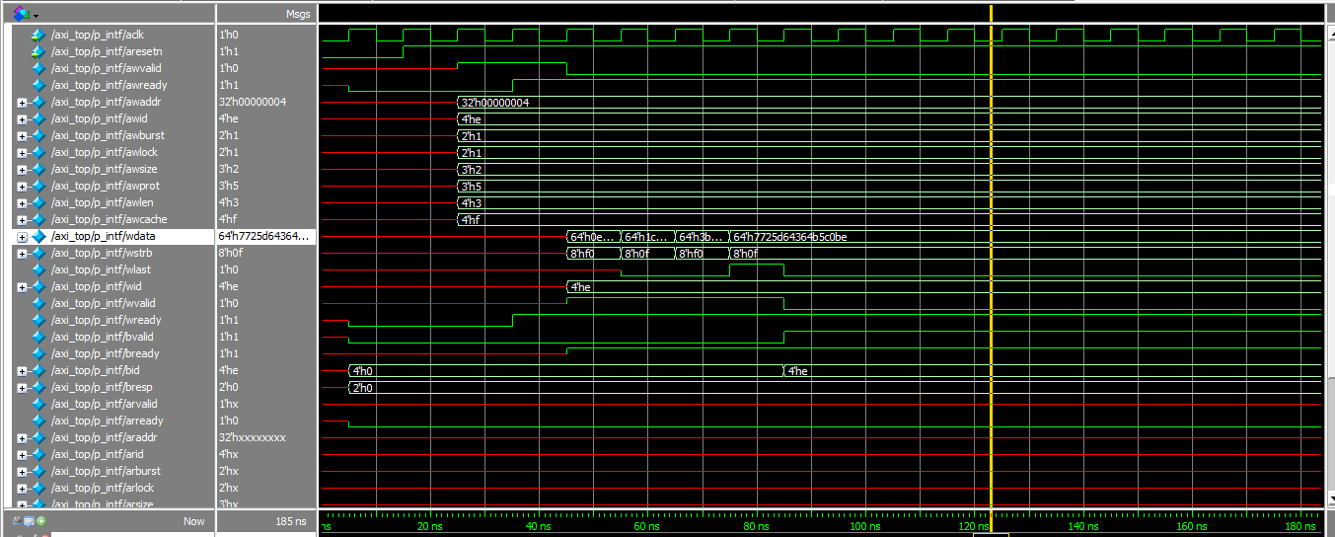

In above waveform bvalid and wready always high, but we need to make only 1 clock cycle high after need to make 0.
- We added after frever below code
- V_s_intf.wread<=0;
- V_s_intf.bvalid<=0;
- Inituiali we are setting if any time will send wreday and bvalid 1 it will override 0 to 1, if didn’t send 1 then maitaine 0 or moving from 1 to 0
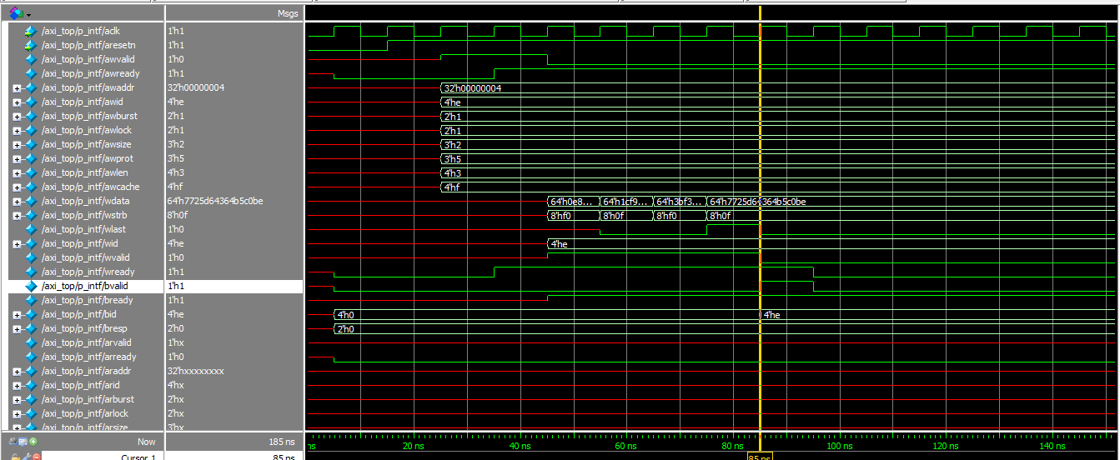
Multiple write transaction:
Sequence:
for(int i=0; i<10; i++)begin
`uvm_do_with(req,{req.w_r==WRITE_ONLY; req.awaddr<9000; req.awvalid==1; req.wvalid==1; req.wid==awid; req.awburst==1; req.awsize<=3;});//awaddr=radom every signal updates some random value
End
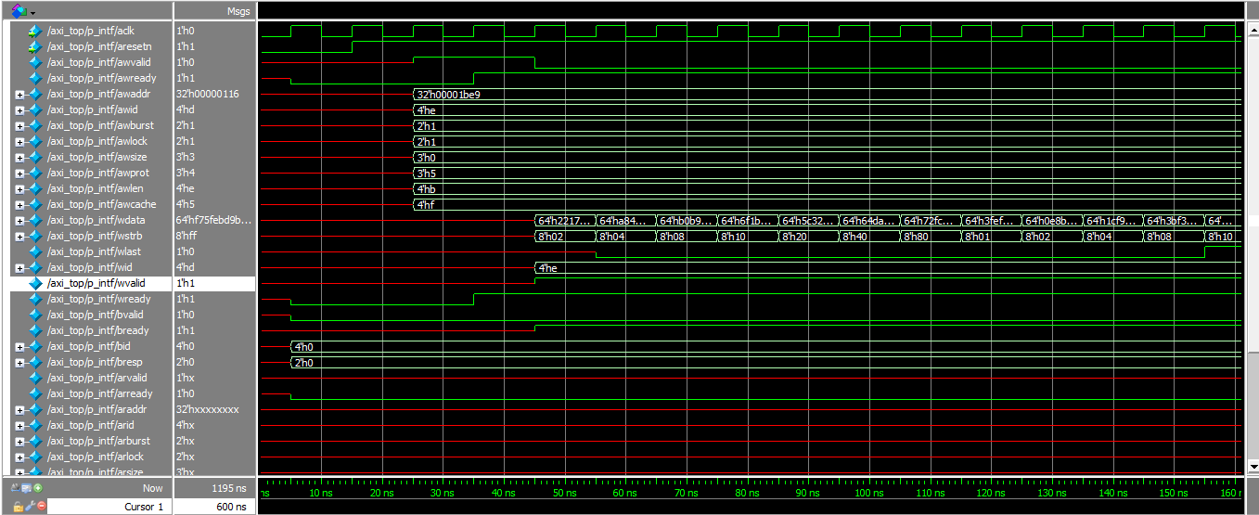
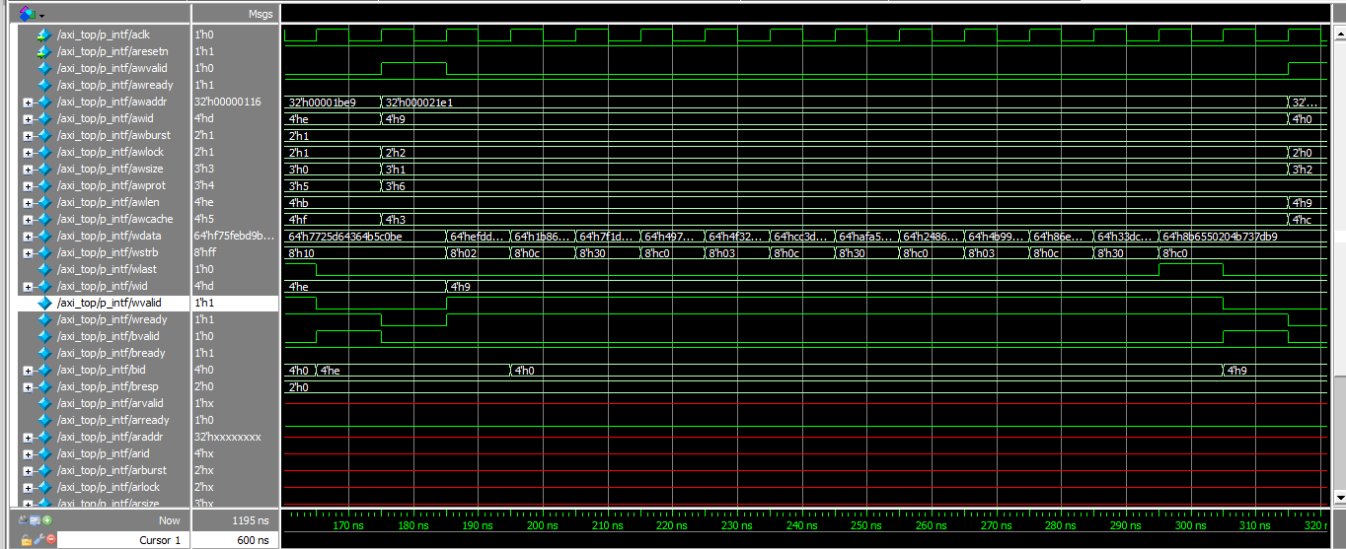
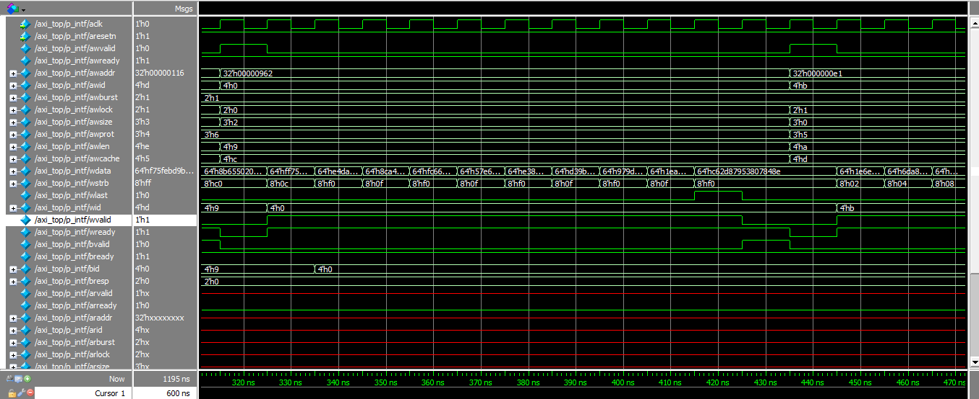
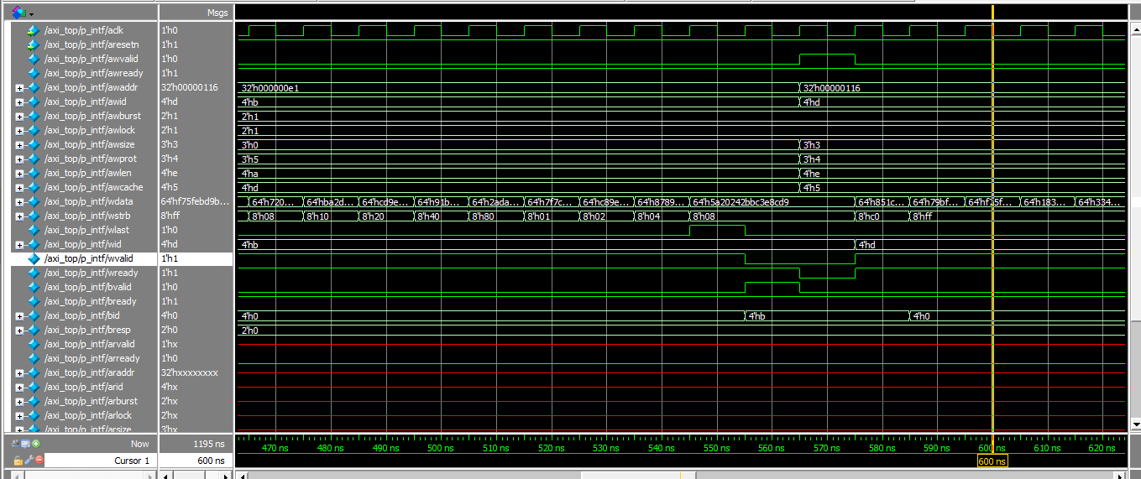
Analyse all transaction wstrb is proper or not w.r.t awaddr and awsize
Full wave form look like below AWID, WID and 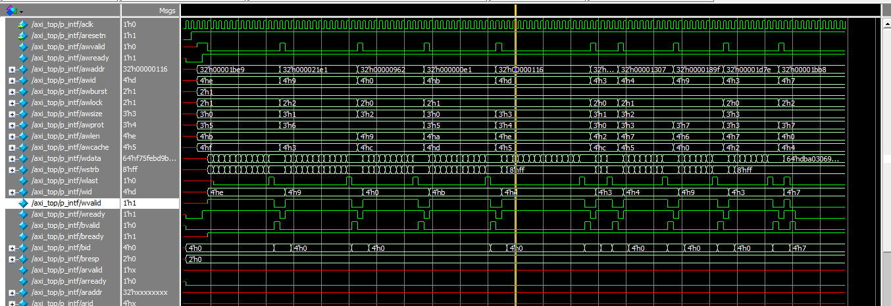BID verified its working
Single write and read sequence
//narrow transfer wr_Rd
`uvm_do_with(req,{req.w_r==WRITE_THEN_READ; req.awaddr<9000; req.awvalid==1; req.wvalid==1; req.wid==awid; req.awburst==1; req.awsize<=2; req.araddr==req.awaddr; req.arlen==req.awlen; req.arsize==req.awsize; req.arburst==1; req.arvalid==1;});//awaddr=radom every signal updates some random value
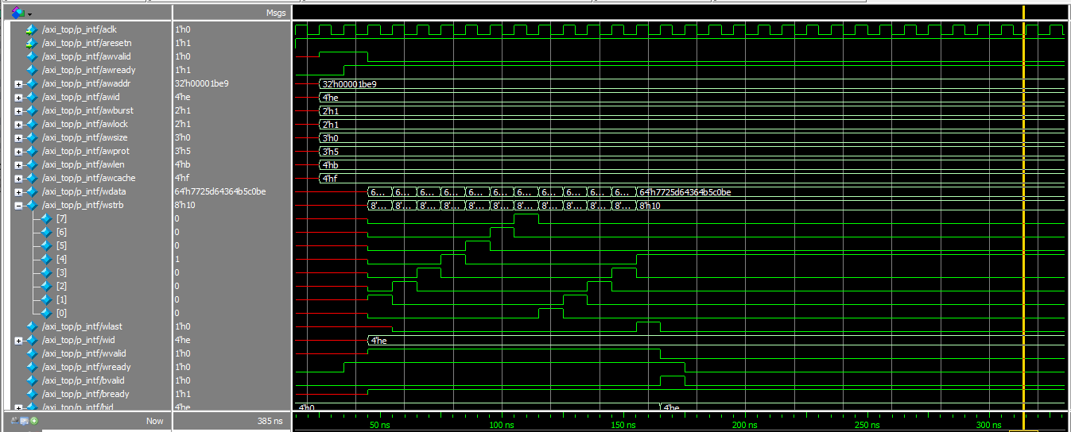
Write
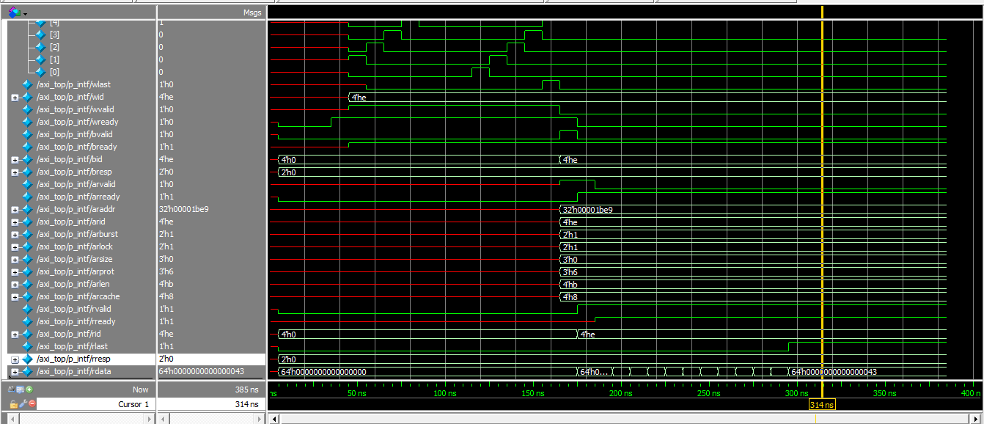
Read

rlast only high at one clock cyle after addeding v_s_intf.rlast<=0 in for loop
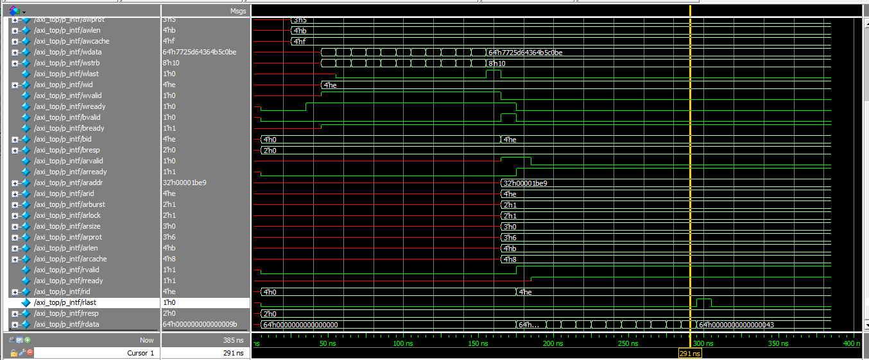

TESTCASE2: INCREMENT TRANSACTION, MULTIPLE WRITE AND READ, ALIGNED ADDRESS, FULL STROBE
class increment_aligned_sequence extends axi_top_sequence;
`uvm_object_utils(increment_aligned_sequence)
int a;
int size;
function new(string name="");
super.new(name);
endfunction
task body();
for(int i=0; i<10; i++)begin

`uvm_do_with(req,{req.w_r==WRITE_THEN_READ;awaddr<9000; (awaddr % 2**awsize)==0; req.awvalid==1; req.wvalid==1; req.wid==awid; req.awburst==1; req.awsize==3; req.awlen==3; req.araddr==req.awaddr; req.arlen==req.awlen; req.arsize==req.awsize; req.arburst==1; req.arvalid==1;});
end
endtask
endclass

Observation
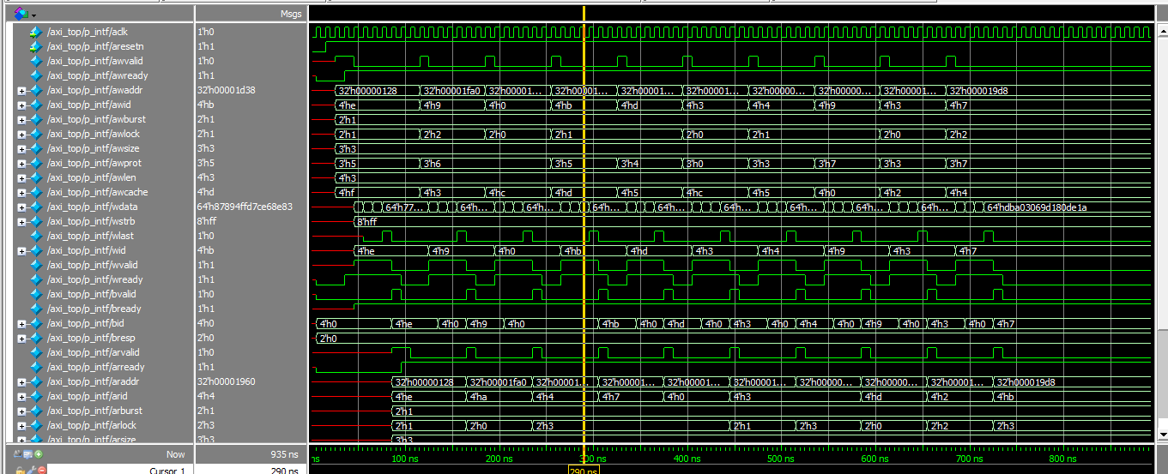
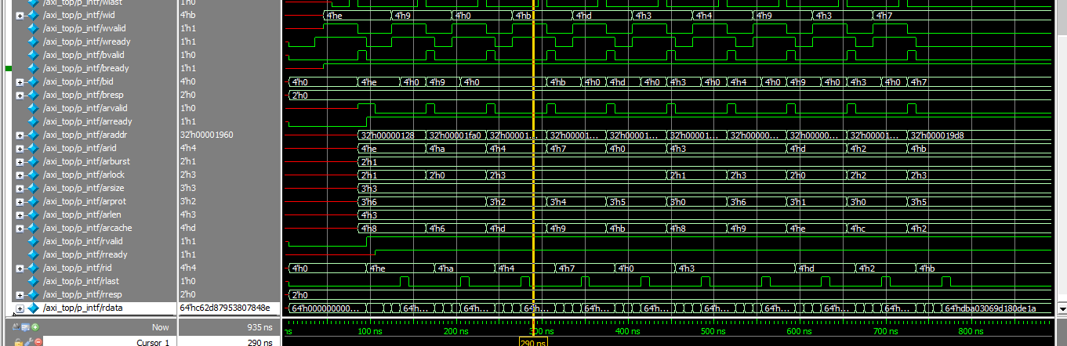

TESTCASE3: INCRMENT MULTIPLE WRITE AND READ, ALIGNED, NARROW TRANSFER
class increment_aligned_narrow_sequence extends axi_top_sequence;
`uvm_object_utils(increment_aligned_narrow_sequence)
int a;
int size;
function new(string name="");
super.new(name);
endfunction
task body();
for(int i=0; i<10; i++)begin
`uvm_do_with(req,{req.w_r==WRITE_THEN_READ;awaddr<9000; (awaddr % 2**awsize)==0; req.awvalid==1; req.wvalid==1; req.wid==awid; req.awburst==1; req.awsize<=2; req.awlen==3; req.araddr==req.awaddr; req.arlen==req.awlen; req.arsize==req.awsize; req.arburst==1; req.arvalid==1;});
end
endtask
endclass

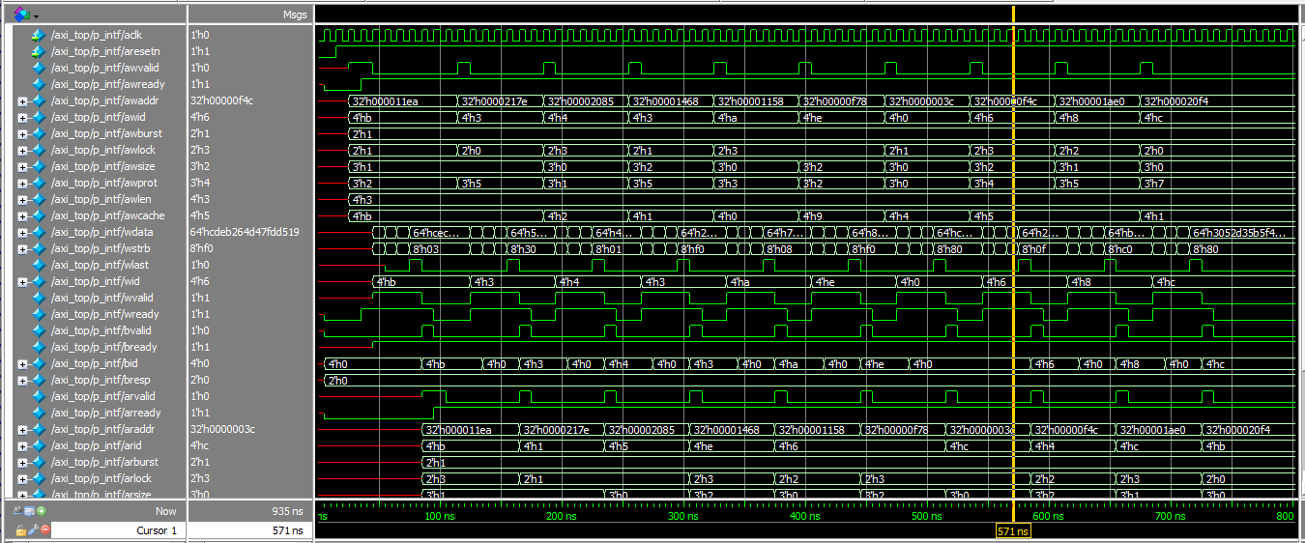
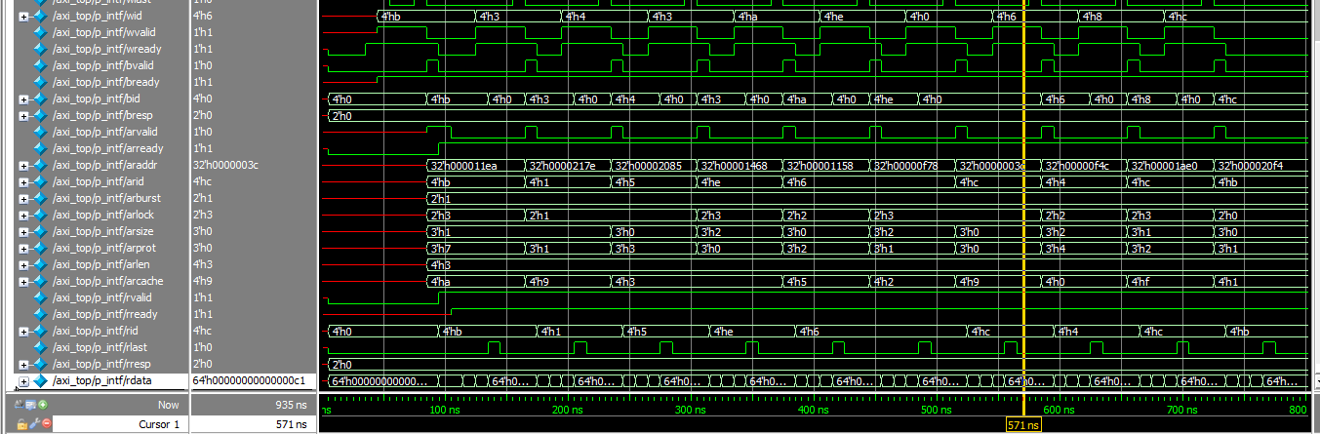

Sequence4:
class increment_unaligned_sequence extends axi_top_sequence;
`uvm_object_utils(increment_unaligned_sequence)
int a;
int size;
function new(string name="");
super.new(name);
endfunction
task body();
for(int i=0; i<10; i++)begin
`uvm_do_with(req,{req.w_r==WRITE_THEN_READ;awaddr<9000; (awaddr % 2**awsize)!=0; req.awvalid==1; req.wvalid==1; req.wid==awid; req.awburst==1; req.awsize==3; req.awlen==3; req.araddr==req.awaddr; req.arlen==req.awlen; req.arsize==req.awsize; req.arburst==1; req.arvalid==1;});
end
endtask
endclass
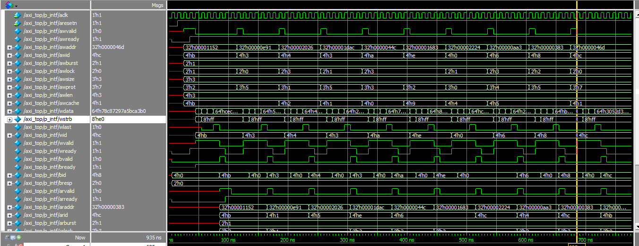
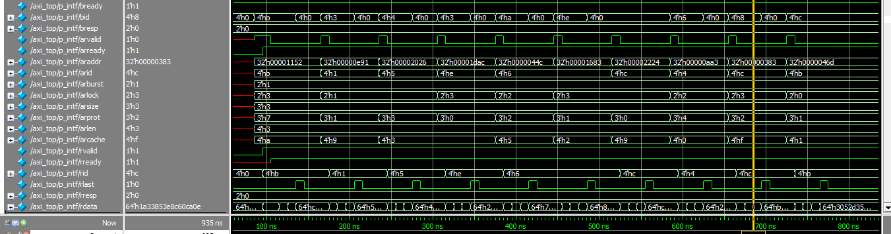

OVERLAPPING WRITE TRANSACTION
